Staff Report

Meeting Date: May 7, 2024
To: Siskiyou County Board of Supervisors
From: Bernadette Cizin, Associate Planner
Subject: Spring Hill Mine, proposed expansion into county jurisdiction

Background
Spring Hill Mine is a permitted surface mining operation located East of Spring Hill Drive within the city of Mt. Shasta. The mine was originally permitted under UP-8-80 by Siskiyou County. It was later annexed into the City of Mt. Shasta as part of the Springhill Annexation on April 3, 1987. In May of 1996 the City of Mt. Shasta Planning Commission approved a Use Permit for aggregate crushing and screening operations along with a concrete batch plant at the existing surface mine site.
Greg Juell, owner/operator of Spring Hill Mine, has contacted county planning staff to discuss his intent to expand the surface mining operation into adjacent property that is within county jurisdiction. The current mine site is completely within Mt. Shasta city limits. The proposal is to expand the area of surface mining into an adjacent 160-acre parcel zoned for Timber Production. Timber Production Zoning allows for extraction of mineral resources with a Conditional Use Permit (County Code Section 10-6.5103(d)). The proposed expansion would not alter or relocate the existing processing equipment and facilities.
SMARA (Surface Mining and Reclamation Act) does not allow two lead agencies for a surface mine unless it is separated by natural or manmade barriers which coincide with the agency boundaries. There are no barriers between the existing mine site and proposed expansion area. Therefore, either property should be annexed to avoid the issue of two different jurisdictions. Alternatively, the city of Mt. Shasta and the county could come to an agreement as to which agency will be the lead agency for this multijurisdictional mine. In doing so, it should be agreed upon that the lead agency will process the Use Permit and Reclamation Plan amendments, have permitting authority and CEQA determination authority for the entire project, including the portion not within their jurisdictional boundaries. Should the city and the county not come to an agreement, the operator or one of the agencies should submit the matter to the State Mining and Geology Board (SMGB) where there will be a hearing to determine which agency shall serve as the lead agency.

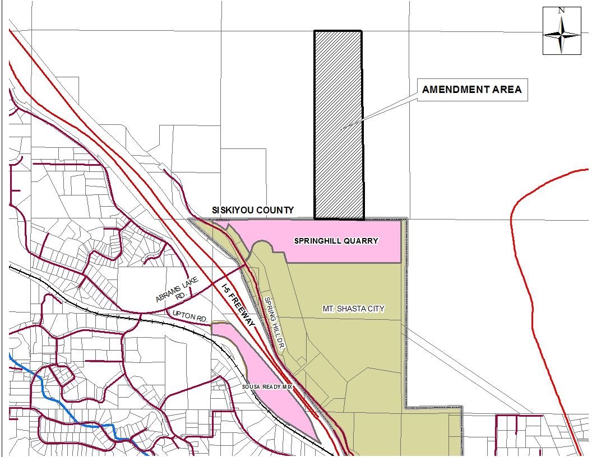
Figure 1: Location Map

Recommended Action
Direct Planning staff as to what the Board would like for the county’s role to be regarding the permitting, oversight and enforcement of the Spring Hill Mine. The following recommendations are included for discussion and direction:
- Support efforts to have the parcel that is the expansion area (county jurisdiction) of the mine annexed to the city of Mt. Shasta. Mt. Shasta will remain the lead agency.
- Support efforts to have the parcel that is the existing mine (city jurisdiction) annexed to the county. Siskiyou County will become the lead agency.
- Work with the city on an agreement for the city to remain the lead agency and have permitting and enforcement authority of the entire mine site, including the expansion area that is within the county’s jurisdiction.
- Work with the city on an agreement for the county to become the lead agency and have permitting and enforcement authority of the entire mine site, including the existing Spring Hill Mine that is within the city’s jurisdiction.
County Planning staff recommends the mine owner further explore the option of annexation. Staff believe taking on the role and responsibility of Lead Agency for a mining operation that is outside of county jurisdiction and tax base would not be in the best interest of the county.

Attachments
- Site Map
- Existing Permitting Documents
- County Issued Use Permit (UP-8-80)
- Reclamation Plan
- City approval of county issued Use Permit
- City Issued Use Permit

